**Exercise 4: Online Bookstore - Processing Request Body and Form Data**

Business Scenario:

Create endpoints to accept and process JSON request bodies and form data for customer registrations.

1. **Request Body:**

* I implemented a POST endpoint to create a new customer by accepting a JSON request body.

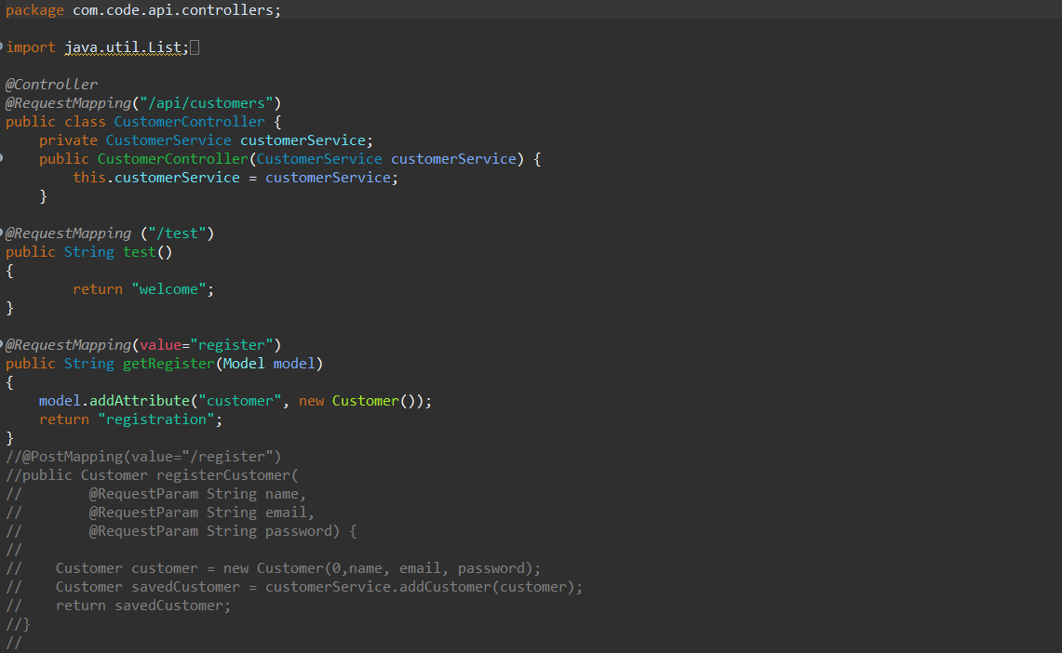

1. **Form Data:**

* I implemented an endpoint to process form data for customer registrations.

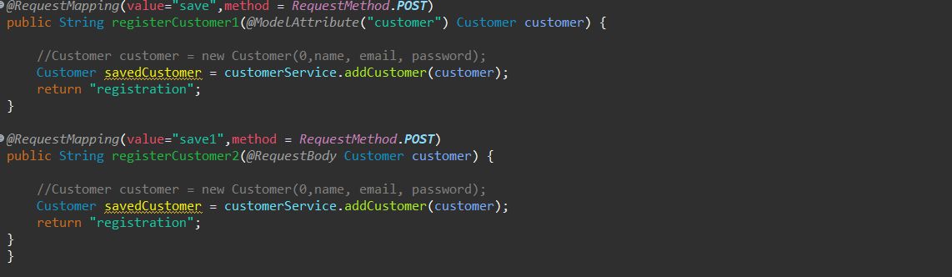

**Output:**

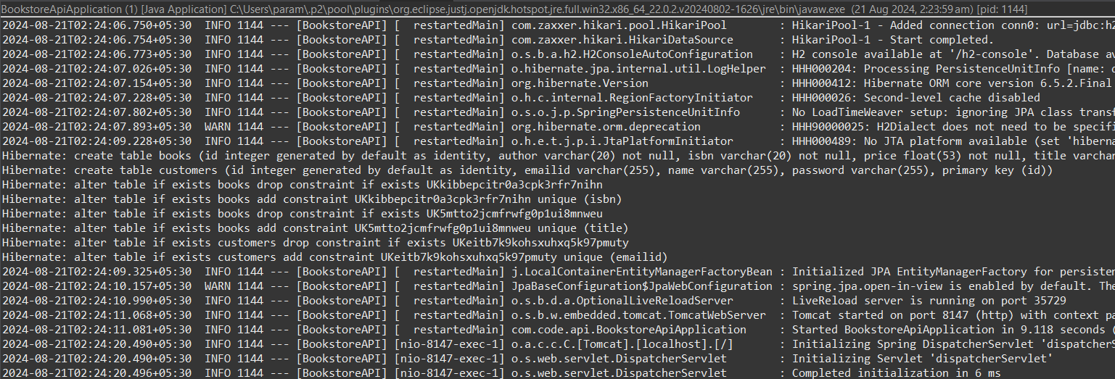

**Opening Chrome and typing the url:** [**http://localhost:8147/api/customers/test**](http://localhost:8147/api/customers/test)

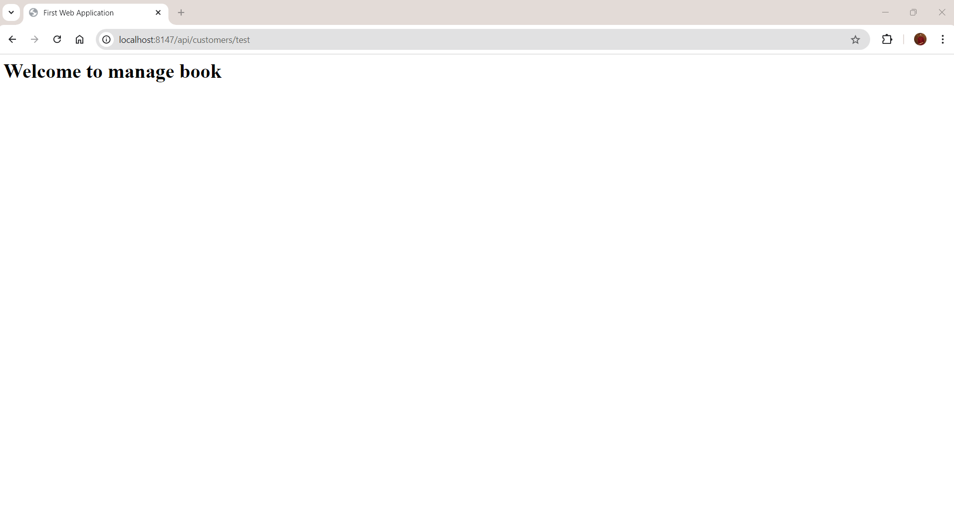

Next registering a new customer by entering the url: [**http://localhost:8147/api/customers/register**](http://localhost:8147/api/customers/register)

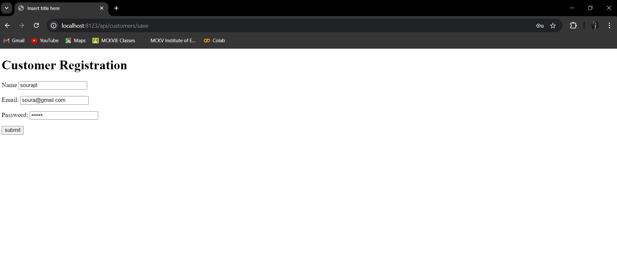

In the IDE the following output is displayed after the operations:

